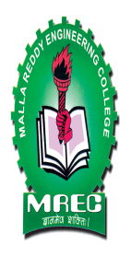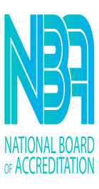 | MALLA REDDY ENGINEERING COLLEGE (Autonomous)  ( An Autonomous Institution approved by UGC and Affiliated to JNTU Hyderabad, Accredited by NACC with ‘A++’ Grade, Accredited by NBA, Maisammaguda, Dhulapally, (Post,Via Kompally), Secunderabad – 500100 Ph:040-64634234). | 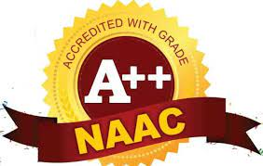

Name of the Lab: | DATA MINING LAB
Lab In-charge: | Mr. E. Sunil / Mr. Vara Prasad
Lab Location: | G06
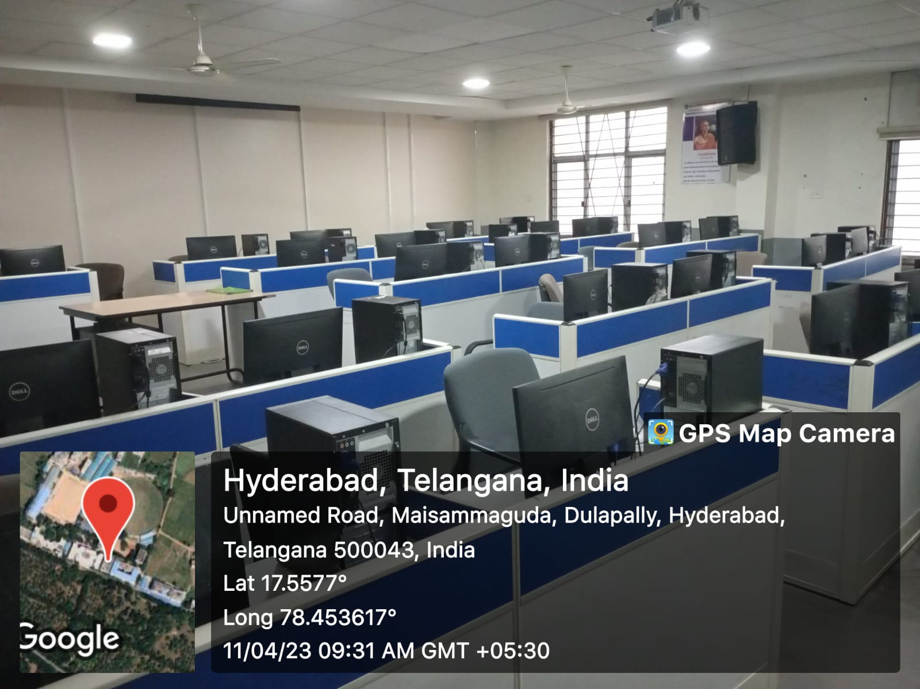
DM LAB

